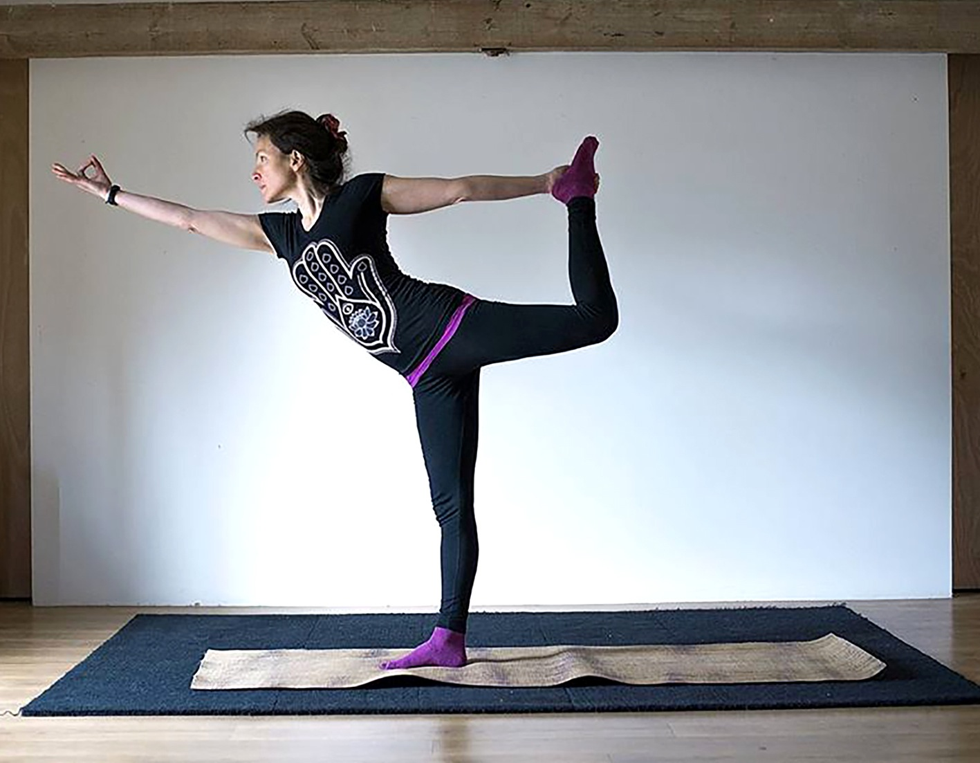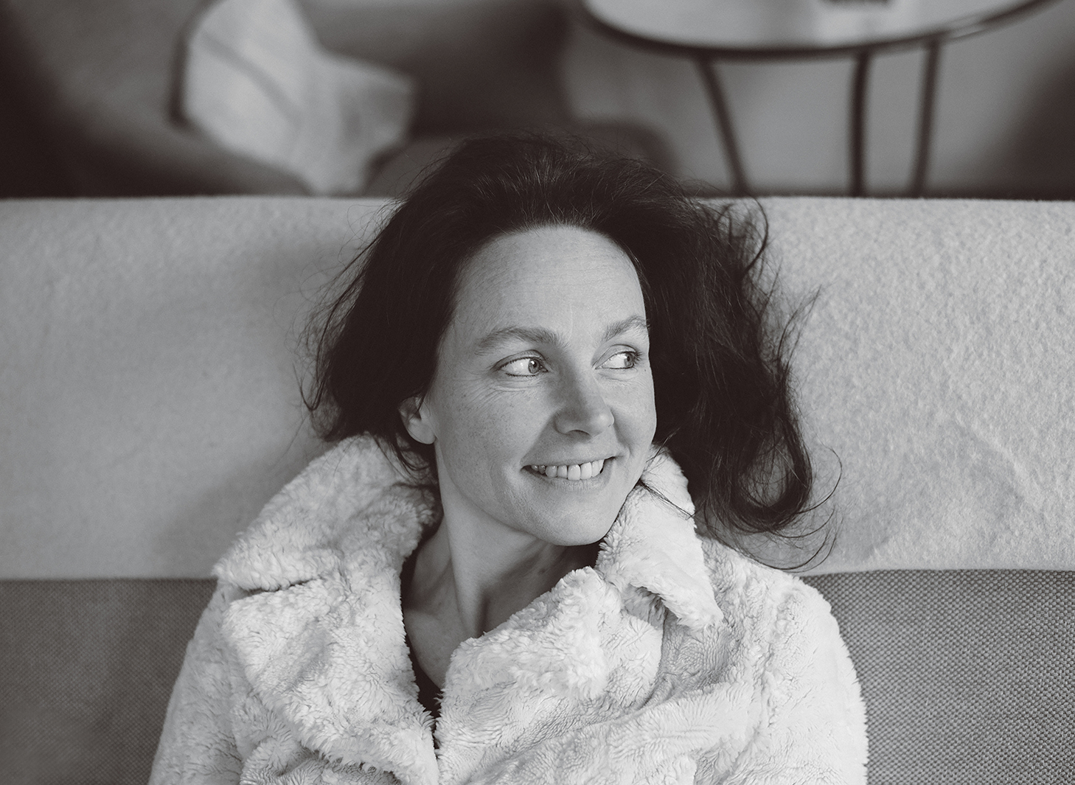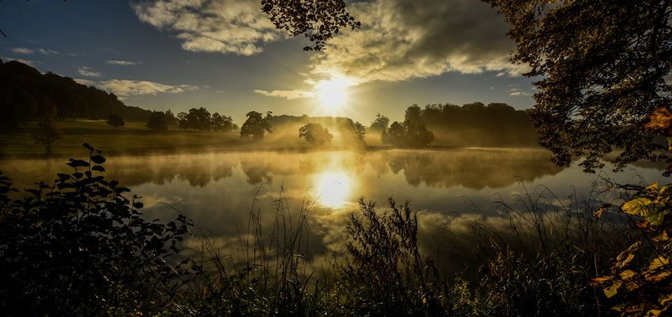

January 29th-31st 2017

Rejuvenate your mind and body with this 3 day inclusive that incorporates, Yoga, guided meditation, Intuitive bodywork, massage and beautiful walks.

Delicious and nutritious food by Steve from Food for Thought.

Anouchka’s intuitive and extensive knowledge of the body will access your potential for movement releasing patterns of constriction. Her informative and sensitive teaching will guide you to increased awareness of your body’s flexibility, strength, mobility and freedom.

You are able to stay at The Beckford Arms or Ashley Wood farm situated in the heart of The Fonthill Estate.

Please call 07956 313332 for further details or email me at spirotonics@aol.com

Yoga Retreat with Anouchka

Photo by Mick Lewis

Photos by Suki Zoe